A modular robotic arm configuration design algorithm based on prioritized experience playback and Double DQN algorithm
NAME,,,,
School of Mechanical Engineering, University of shanghai science and technology, Shanghai, China
*Corresponding author: XXXXX@st.usst.edu.cn
Keywords: Modular reconfigurable robotic arm; Double DQN; Preferential experience playback; Deep reinforcement learning
Abstract.This paper proposes a Double-DQN-based design algorithm for reconfiguring the configuration of a modular robotic arm with preferred experience playback, which aims to find the optimal configuration of the robotic arm under different tasks. Firstly, a library of small modules of collaborative robotic arms consisting of multiple tandem robotic arms is constructed. These modules are described in XML format and can be imported into the software for simulation. Subsequently, the Double DQN design framework is used to solve the overestimation problem in traditional reinforcement learning methods. The value function of each module can be estimated more accurately through the use of Double DQN to obtain the optimal robotic arm configuration. In addition, the experience playback mechanism is improved based on SumTree to achieve preferred experience playback, which enables the algorithm to make effective use of historical experience and avoids the algorithm from falling into local optimal solutions. At last, comparative experiments are carried out on the PyBullet simulation platform to verify the effectiveness and superiority of the proposed method. The simulation results show that the method has higher search efficiency and accuracy. The research results provide new solution ideas and tools for the robot configuration search problem, and promote the development of intelligence and automation in the field of robot applications.
Keywords: Modular reconfigurable robotic arm; Double DQN; Preferential experience playback; Deep reinforcement learning

Introduction
Compared with the traditional robotic arm, the structure of modular robotic arm is characterised by its ability of adapting flexibly to the reconfiguration of different complex environments. Each module contains specific functions and achieve quantification, and through flexible combination and replacement, requirements of different fields and application scenarios can be achieved. The functions of the arm can be assembled and reconfigured twice or several times in the face of different scales and types of tasks, without the purchase of new functional mechanical equipment, which minimises the consumption cost. For this reason, it can effectively assist operations in the industrial, aerospace, and logistics fields. This modular design enables the robot system to be more flexibility, scalability, and capable of being customised and adapted according to the requirements of the practical environment. Nevertheless, during the construction of a modular robotic arm, the number of available modular reconfiguration models exponentially increases as the number of module types and connection methods increase. Reconfiguration models need to be accurately assessed with respect to their ability to fulfil the task in a large design space. This assessment involves the planning and comparison of comparative motion costs between candidate design models, which consequently leads to the computational scale becoming excessively large, therefore efficient algorithms and techniques are required to accelerate the design evaluation system and find the optimal modular configuration to achieve effective functionality of the modular robot for a given task.
Under the continuous development of information technology, with reinforcement Learning as the representative of intelligent algorithms, with the characteristics of its self-adaptability, as well as with the ability to enable the robot to constantly trial and error, exploration, as well as the establishment of the corresponding reward and punishment mechanism, instead of other algorithms are more be applied to the field of robot control, in order to enhance the machine learning algorithms based on the changing of its own tasks and the environment, to constantly update their own adjustments to the flexible control strategy.Luo et al. proposed a self-reconfiguration algorithm based on a spherical modular robot for helping to cross various types of obstacles [3]. Whitman et al. proposed a DQN-best-first search algorithm based on the Deep Q Network (DQN) algorithm in deep reinforcement learning, by which the intelligence trained by the algorithm can solve the robot configuration synthesis problem and, in terms of execution efficiency, are superior to existing search algorithms [4]. However, the traditional DQN algorithm requires a large number of samples in the training process, which leads to the problem of low sampling efficiency, and the instability of its optimization process also causes the volatility of the training results and is prone to over-estimation and other problems.
To solve the above mentioned problems, some new improvement solutions have been successively proposed based on the DQN algorithm. A Double DQN algorithm was firstly proposed by Chen Zesheng et al. to solve the over-estimation problem of the traditional DQN, and according to the comparison of the results of the simulation experiments based on the interference pattern selection method, the DDQN algorithm performs superior compared with the DQN algorithm [9]. In the second place, Schaul et al. proposed a preferred experience playback idea, which can be applied to the algorithm to enable it to make effective use of historical experience [5].For further improvement, Zhai et al. proposed an algorithm that combines the Double DQN algorithm with the preferred experience playback idea. Compared with the traditional DQN algorithm, it utilises the preferred experience playback idea, which improves the convergence speed and ensures that the algorithm reaches better obstacle avoidance results in performing the obstacle avoidance task [6]. Through the integration of the two ideas, the algorithm utilises prior experience to update the model in a more specific and effective scope, which improves the overall performance of the algorithm.
To solve the task of judging and realising the optimal reconstruction of the robotic arm model more conveniently, quickly and with high probability in different complex operation situations, so as to achieve a more efficient calculation of the reconstructed model under the same conditions, while the cost of the reconfiguration model can be minimised, as well as the number of modules in the design configuration can be less, and the quality can be lighter. A Double DQN modular robotic arm reconstruction algorithm with improved preferred experience playback idea is proposed, on which the experience playback mechanism is improved by using SumTree to realise the preferred experience playback, so that the algorithm can make effective use of the historical experience, thus avoiding the algorithm from falling into the local optimal solution [7,8]. The main contributions of this paper include:
- This paper improves the traditional DQN algorithm and proposes the Double DQN algorithm for modular robotic arm configuration design. By using a main network and a target network, the algorithm evaluates the value of each action in the current state and selects the optimal action. The main network is used to calculate the action values in real-time for the current state, while the target network evaluates the action values for future states. Through the adoption of this dual network structure, the algorithm can more accurately estimate the value of actions and avoid the problem of overestimation.
- In order to better utilize historical experience, this article has improved the experience playback mechanism and introduced priority experience playback technology based on SumTree. This playback mechanism can effectively select important experiences for training, prevent the algorithm from falling into local optima in the later stages of training, and thus improve the convergence speed and training efficiency of the algorithm.
(3) Establish a small module library for collaborative robotic arms, which can form various series robotic arms. The model was converted into an XML format URDF robot description file using SolidWorks' SW2URDF plugin, and simulation experiments were conducted on the PyBullet simulation platform to search for the optimal configuration of the robotic arm under different tasks. The experimental results show that this method successfully improves the success rate of searching for feasible configurations and finds lighter and fewer feasible configurations.
This paper aims to investigate the task of searching for the optimal configuration of a robotic arm for different environmental conditions and tasks in a real industrial environment. In the study of modular reconfigurable robots by Jinguo et al, reconfigurable robots can be classified into two categories, which are large reconfigurable robotic arms and small reconfigurable robotic arms [12]. The large-scale reconfigurable robotic arm has the advantages of flexibility, easy maintenance, and interchangeability, which can be more widely used. Therefore, this paper focuses on the tandem structure of a large-scale reconfigurable manipulator arm (Fig.1 branch shown by redarrow).

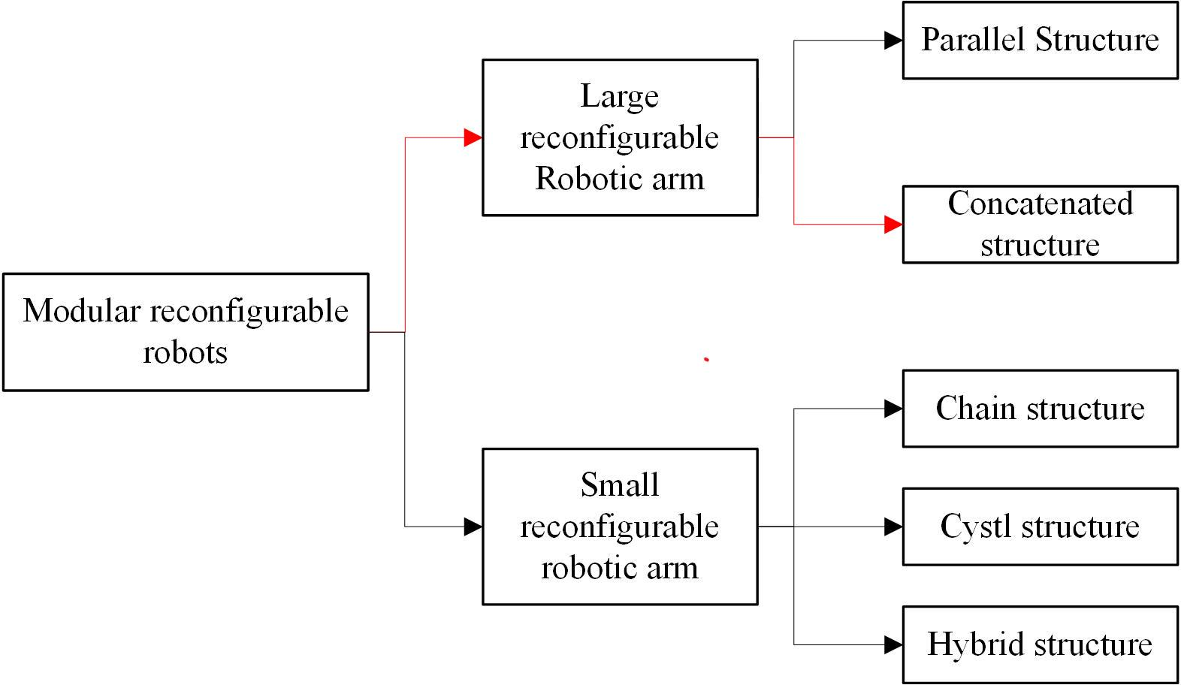
Fig.1 Categories of Modular Reconfigurable Robots

Problem Formulation

2.1 Modelling of MRP
Building a library of robotic arm modules can improve the efficiency of design, reduce the cost, increase the reconfigurability of the system, as well as simplify the maintenance and update process, which leads to greater convenience and flexibility in the development and application of robotic arms. According to relevant design experiences at home and abroad, three specifications of joint modules are usually used: shoulder joint, elbow joint, and wrist joint. At the same time, the mass of each joint is pre-assigned, in which the wrist joint does not exceed 2kg, the elbow joint does not exceed 3kg, and the shoulder joint does not exceed 4.5kg. The predefined parameters of the tandem robotic arm are shown in Fig (Fig.2). The three joint specification size parameters set in this paper are shown in the following table (Table 1).

Table 1.Predefined parameters for tandem robotic arms
Joint type | Diameter | Height | Motion Range
Shoulder Joint | 40mm | 50-70mm | ±160°
Elbow Joint | 36mm | 48-56mm | ±145°
Wrist Joint | 32mm | 38-46mm | Approx. ±120°, Grip: Approx. 0-90°

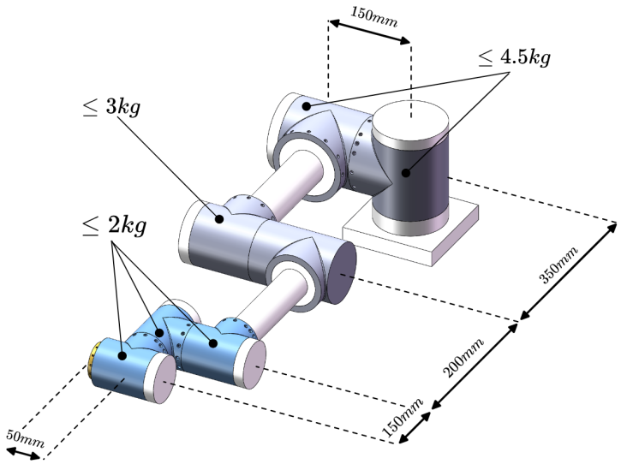
Fig.2 Predefined parameters for tandem robotic arms
A small module library was created by using SolidWorks software, which contains a total of 13 modules, including two models of base modules, three models of active modules, and eight passive modules with different size and shape (Fig. 3). At the same time, the SW2URDF plug-in in SolidWorks was used to convert these models into URDF (Unified Robot Description Format) robot description files as XML format, so that the relevant training environment could be built in Pybullet simulation software to conduct simulation experiments.
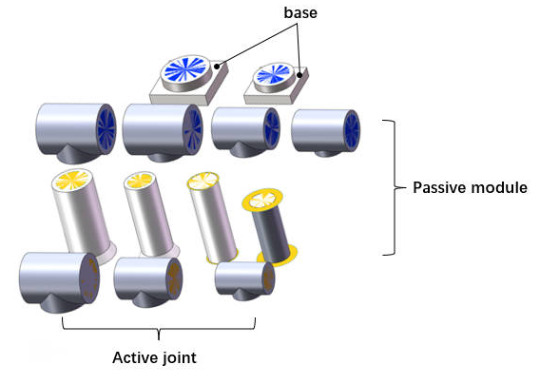
Fig.3 Robotic Arm Small Module Library

URDF is an XML file format for describing robot models. It can organise the physical, kinematic and visual attributes of the robot model, including information about joints, sensors, colliders, inertia, links, etc. URDF files could be imported into robot simulation software such as Gazebo, PyBullet, etc., in order to load and simulate the robot model. Each joint module in this paper has a standard input/output interface, using the characteristics of the URDF file, the "virtual linkage" can be defined by saving the input/output interface information in its corresponding URDF file [10]. For example, the T-joint module is shown in the figure below, where the orange "virtual links" indicate the output interfaces and the blue "virtual links" indicate the input interfaces, and the coordinate system definition rule of URDF requires that the geometry of the "virtual links" is defined in the URDF file of each "virtual link". The rules for defining the URDF coordinate system require that a coordinate system be established at the geometric centre of each "virtual link", with the axes of the coordinate system parallel to the direction of the normal to the surface of the "virtual link" (in the direction of the z-axis). For output interfaces, the axis of the coordinate system points outwards, while for input interfaces, the axis of the coordinate system points inwards. (Fig.4)
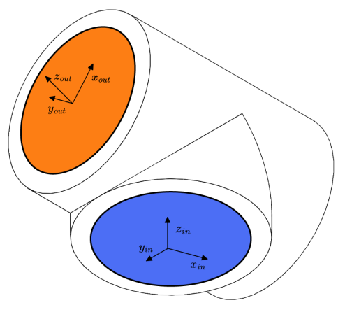
Fig.4 Coordinate definition of the T-joint module

To assemble multiple modules into a complete robot, it is necessary to define the assembly rules between URDF files. Taking the assembly between two T-joint models as an instance, the assembly is completed when the output coordinate system {out} of module {i-1} coincides with the input coordinate system {in} of module {i}. As shown in the figure below (Fig.5), the red arrow indicates the path, i.e., the output "virtual link" (orange) of module {i-1} is connected to the input "virtual link" (blue) of module {i} to complete the assembly.
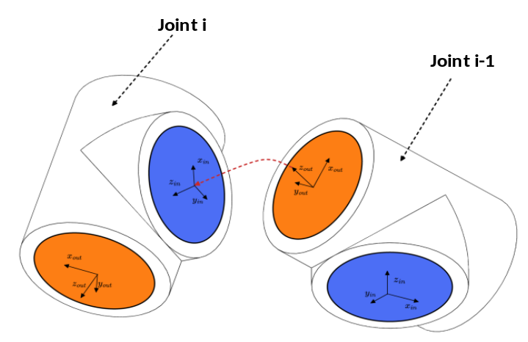
Fig.5 Assembly rules for modules

2.2 Modular Robot Design Based on Reinforcement learning
The design methodology in this paper aims to generate the optimal tandem robotic arm configuration to perform the task based on the given robotic arm module library and the task in different scenarios, and the optimal configuration is determined based on factors including the number of modules and quality of the complete robotic arm. The reconstruction process of the tandem robotic arm is shown in Fig. In this process, the base module is added first, the configuration C is formed by adding new joint modules to the base module, the new configuration C' is formed by continuing to add modules from the configuration library to the configuration C, and the configuration that ends only with the end-effector module is defined as the complete configuration. (Fig.6)
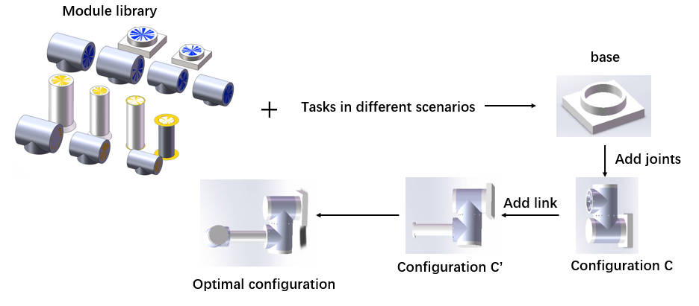
Fig.6 Reconfiguration process diagram of the tandem robotic arm

The configuration design problem of a modular tandem robotic arm can be modelled and resolved by using the Finite Markov Decision Process (MDP). Set up a quaternion structure, where S denotes the set of state values of the environment, defined by the set of robotic arm configurations. The action space A is defined by the available robot module library. R denotes the reward value obtained by adopting an action in a particular state, and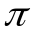represents the strategy function. At each moment , the reinforcement learning intelligence has to select an action, which means selecting the index value of a module 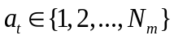and adding the corresponding module to the current configuration . The only part of the state 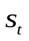 that changes is the configuration , so the state at the next moment depends only on the previous moment's state and the action of adding the module. At this point a new state 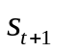 is produced, containing the new configuration C ' and a reward from the environment 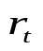. The expected payoff of the reward that the Agent receives for choosing an action in the state is:
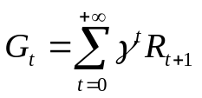
is the discount factor used to calculate the cumulative reward , where the discount factor 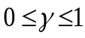, and 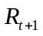 is the value of the environmental reward obtained at time step . The value function of strategy taken at state st is the state value function. The state value function for taking strategy at state it is:
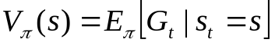
Based on the strategy , action at is used, then the value function of the action in the state it is:
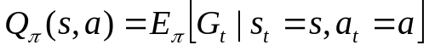
The core made of the algorithm uses reinforcement learning to estimate the optimal state-action-value function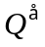, which can be defined by the Bellman optimality equation, the
In reinforcement learning the data and environment are dynamic, through interaction with the environment, the intelligent body can continuously try different actions and evaluate the merits of the actions through the reward signals obtained.

2.3 Deep reinforcement learning DDQN
Q-learning is a reinforcement learning algorithm based on value iteration, which employs a tabular method to compute the valuation of Q-values corresponding to each possible state-action pair. In modular robotic arm configuration design, the high-dimensional continuous state and action space makes the traditional Q-value estimation based on the table method difficult. The Deep Q Network (DQN) was developed to solve this problem[13]. By fitting the Q-value function through a neural network, it can directly input the states and output the Q-value of each action, which avoids the space complexity problem of maintaining a Q-table. At the same time, the nonlinear fitting ability of deep neural networks can better approximate complex Q-value functions.
Traditional DQN employs two neural networks with the same topology but different parameters. One network is used to update the parameters in real time while the second network is utilized to update the target Q-value. The updating formula for the target Q-value is:
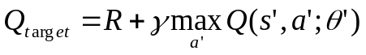
Yet ordinary DQN algorithms find the largest Q value for each action from the target Q network, which will select the overestimated value with a high probability, which in turn leads to the overestimation problem. The Deepmind team proposed DDQN in 2015 to solve this problem by independently training two separate Q-networks [14].Double DQN introduces two separate neural networks (which also have the same structure and different parameters as DQN): one for selecting the actions (the action selection network), and the other for evaluating the value of the selected actions (goal network). Instead of using the target network directly to select the maximum action value for the next state when calculating the target Q value, the action selection network is used to select the action:
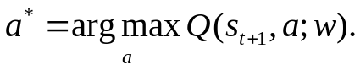
This action is used as the action for calculating the target Q value, and the selection of the optimal action is accomplished using the target network. The calculation of the target Q in Double DQN is shown in equation :
In this paper, the principle of Double DQN is applied to the modular robotic arm configuration design to solve the high dimensional and complex problem of robotic arm module reconfiguration.

Method

3.1 Double DQN for Module Selection
The aim of this paper is to find the optimal configuration of a robotic arm for different tasks to reach the specified task point accurately. The robotic arm consists of a set of 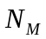 modules with module index 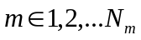. As a result, the problem of configuration optimisation of a modular reconfigurable robot can be formulated as: selecting a sequence of modules, the configuration consisting of these modules in order, is able to perform the given task.The metrics and functions to assess the optimality of the robotic arm in this paper are given below.
- Target point accessibility
The workspace objective (positional pose) is described by the set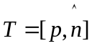, which 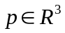denotes the coordinates of the end-effector in space and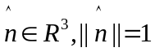denotes the orientation of the end-effector. A sequence of modules C is selected, and to evaluate whether the configuration can reach the given objective, the position error 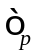 and attitude error 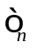 are set according to the joint accuracy of the robot, and definitions 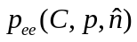 and 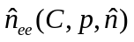 denote the output postures of the inverse kinematics solution corresponding to the positive kinematics for the given objective. The "reachability" function of the configuration C for a given pose is defined by equation:

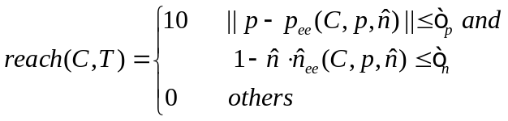
- Conformational state
When the added module is an end-effector, the smart body reaches the termination state, and the environment returns a reward given by the "reachability" function in equation , which is evaluated only for complete configurations, and a penalty of -1 is returned for configurations that do not have an end-effector added to the termination state ( the maximum number of modules in this paper is set to be Nmax=15).
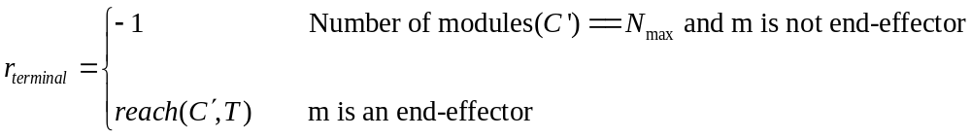
(2)Constraints
As affected by the mechanical structure and joint driving ability and other factors, the joint angle of each joint of the robotic arm has a certain constraint range, and the constraint of the joint angle range is defined as:
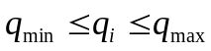
In which: 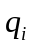 is the inverse kinematics solution of the reconfigurable robotic arm; 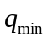 and 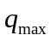 are the joint angles' minimum and maximum values, respectively.
(3)Optimal Configuration
The ultimate goal of evaluating the robotic arm configuration is to find the optimal configuration 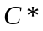 that achieves the goal. It is also desirable to have a robot with fewer drive modules and a lighter mass. The resulting definition of the objective function  is given by the equation:
where 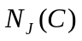 denotes the number of drive joints in a given robotic arm configuration , 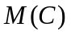denotes the total mass of the configuration , and 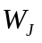 and 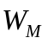are the weighting factors for the number of drive modules and the total mass of the configuration respectively, to trade-off between multiple objectives. The optimal configuration C* is defined as given by the equation.
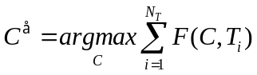
In this paper, the above metrics and functions are applied to the interaction between the intelligent body and the environment to gradually learn how to maximize the cumulative rewards by choosing the optimal actions. The training interaction process is shown in Figure (Fig.9), in which the DDQN intelligent body selects the next robot module to be assembled based on the list of states and submodule constraints provided by the simulation training environment. The environment immediately adds the module to the current configuration and returns the state, reward signal, termination signal, and list of submodules for the next moment.
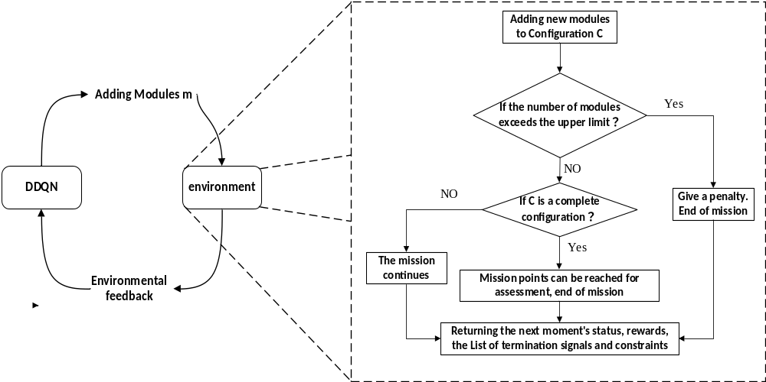Fig.7 Flowchart of optimal configuration design

3.2 Modified Double DQN with SumTree
The traditional empirical playback mechanism blocks the relevance of the training samples, and the uniform sampling is not conducive to filtering out the quality samples, which is not beneficial to the convergence of the algorithm. In addition, the traditional sampling method needs to sort all the samples, which is very power-consuming. For better sampling, this paper adopts the preferred empirical playback method based on SumTree for solving the problem[15]. SumTree is a special binary tree data structure (Fig.8). There are four layers of node structure in SumTree, the top node is called the root node. The middle two rows are called parent nodes and the bottom row is called leaf node. All empirical samples are stored in the leaf nodes, which also store the priority of the samples.

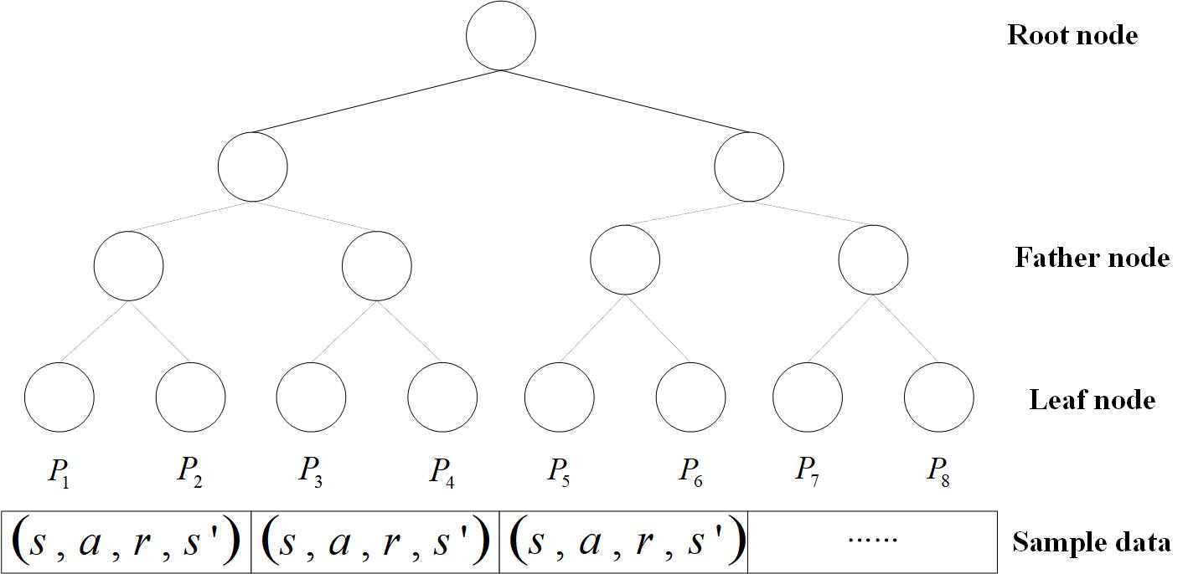
Fig.8 Sumtree structure diagram

The amount of the temporal difference error (TD error) determines the priority of the samples in SumTree sampling, and the larger the TD error, the higher the priority. The value of the TD error shows the strength of the neural network's back propagation effect.The following are the priority of experience and its probability of selection：
:

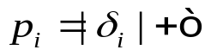
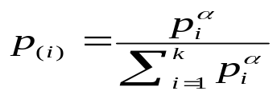

, the TD error, is a very small number that prevents the probability from being equal to 0, where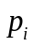is the experience's priority .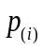 is the probability that the sampling experience is selected; is a hyperparameter that controls the sampling preference in uniform and greedy sampling; And 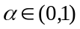. When it is 0, sampling is uniform; When it is 1, sampling is greedy.
The estimation of the action value function is inaccurate when sampling with a probability distribution that favors playback. To adjust for this bias, one must multiply by a significance sampling coefficient because the distributions of the action value function and the sampling distribution are two entirely distinct distributions.
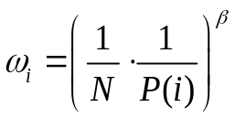
The multitasking issue in the reconfiguration of a modular robotic arm is resolved in this study using the Double DQN algorithm with preferential experience replay. The quantity of experience needed for learning is decreased by using Priority Experience Replay (PER). Mini-batches are given priority weights in the training set, which helps to shorten the model's training time and the number of training iterations (Fig. 9). The effectiveness and performance benefits of the strategy are confirmed in this research by additional simulation studies.
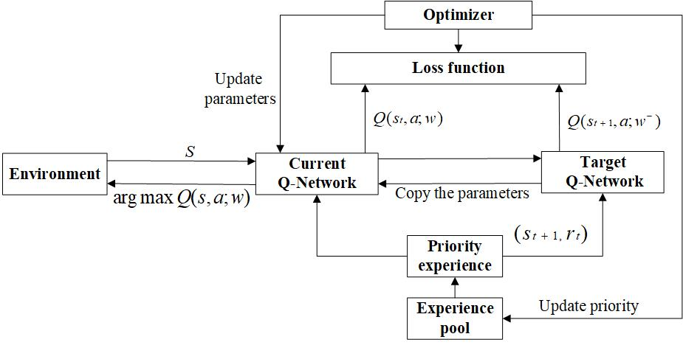
Fig.9 Schematic of the DDQN algorithm with prioritized experience playback

3.3 Modular Robotic Arm Algorithm Based on Improved DDQN Algorithm
In this experiment, the input to the neural network consists of the current configuration C, the workspace T, and the constraints O. These three tensors are concatenated by the Concatenate operation after a layer of fully-connected layers to generate a combined input tensor. The three fully connected layers are activated using ReLU as the activation function, which is applied after the output of each layer, setting negative values to zero and keeping positive values constant. The final output is a state-behavior value for each module Q. The state-behavior value Q is used to guide the decision-making process, helping the intelligence to select the next robot module to be assembled and to maximize the cumulative rewards within the given constraints. The structure of the neural network is described. (Fig.10)

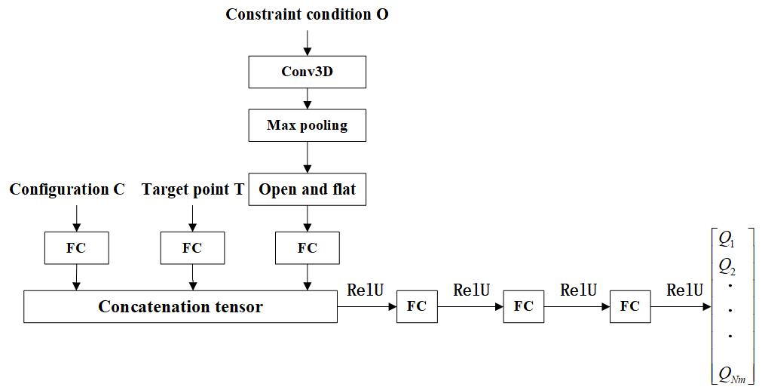
Fig.10 Schematic diagram of neural network structure

The Double DQN algorithm with preferred experience playback is applied to modular robotic arm configuration design in this paper, with the flow of the algorithmic model shown in figure (Fig. 11) To obtain the optimal configuration under different tasks, the algorithm adopts the current configuration's state information, constraints and reward signals as the inputs and is fitted with a neural network to get the  value corresponding to the selection of each module. A module is selected according to a greedy strategy to evaluate the obtained new configuration and obtain the reward .The value is updated by the return value to decide the module to be selected for the next stage of work, and then the four variables mentioned above are deposited into a quaternion of samples 〈s, a，r，s'〉, and the multiple samples from the sample pool. A certain batch of samples is taken from the sample pool according to the priority weights to train the neural network and update the network parameters. Then the module selection is carried out again and the cycle is repeated until the termination state is reached. Through this iterative training process, the algorithm can continuously optimize the configuration selection strategy and find the optimal robotic arm configuration under different tasks.
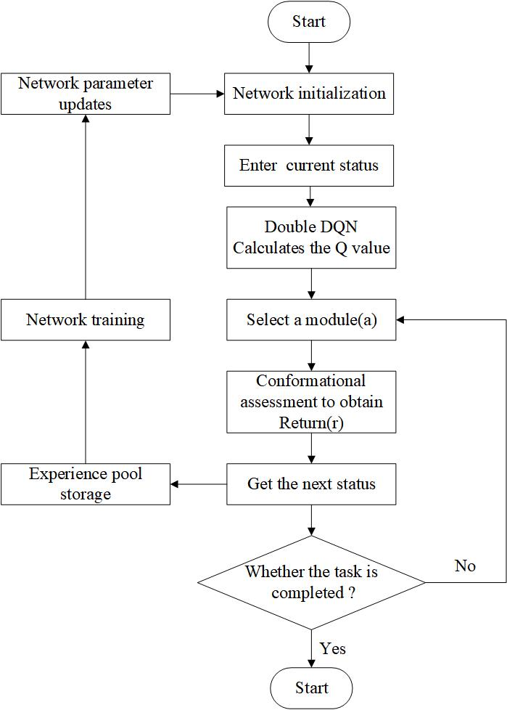
Fig.11 Flowchart of the application of Double DQN algorithm based on priority experience playback

In this paper, we propose a DDQN modular robotic arm reconfiguration algorithm with prioritized experience playback and using SumTree as the experience playback pool, the pseudo-code of this algorithm is shown in Algorithm 1:

Algorithm1：Double DQN with proportional prioritization
1: Input：=(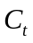，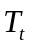，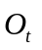)
2: Result: optimal configuration
3: Initialize replay memory 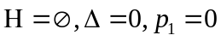
4: Set replay period ,budget T, step size, minibatch 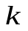and size, exponents
5: Observe Initial state(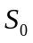) and choose an action 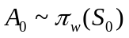
6: for t=1 to T do
7: Observe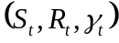in H and set its priority to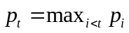
8: Store transition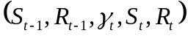
9: if 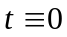 mod then
10: for i=1 to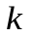do
11: Sample transition 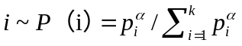
12: Compute the importance sampling weight 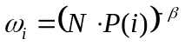
13: Compute TD-error at this sample point
14: Update transition priority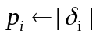
15: Accumulate change in cumulative weight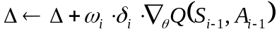
16: end for
17: Update weights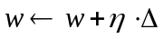, reset 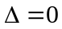
18: At times copy new weights into the target network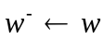
19: end if
20: Choose an action 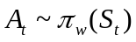
21: end for

Numerical Experiments

4.1 Simulation Environment
In this paper, a custom simulation environment for robot configuration optimization was created using the OpenAI gym reinforcement learning platform and the Pybullet physics engine. The simulation environment defines the obstacle (left) and the task space (right), the obstacle consists of a cube with a prism length 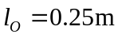, and the task space is defined as a space 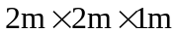 containing the possible locations of the obstacle and the target (Fig.12).
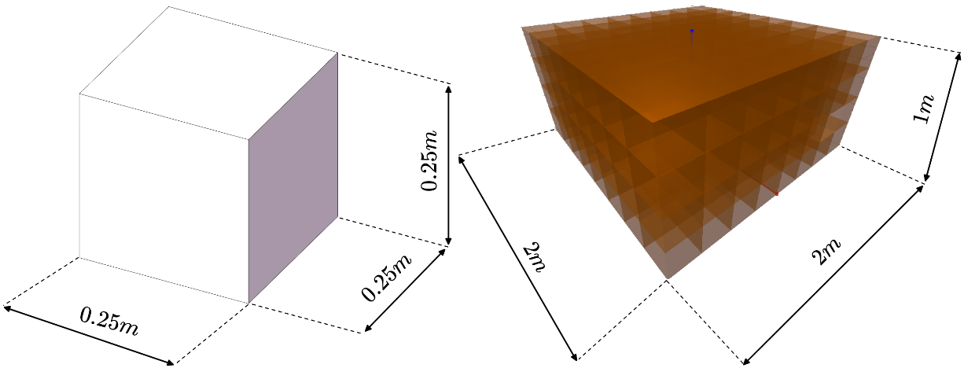
Fig.12 Obstacles and Task Space in Simulated Environments

4.2 Experimental parameter setting
The code is deployed on the Aliyun ECS cloud server for training and the experimental environment is shown in Table (Table 2.)

Table 2. Experimental operating environment
Experimental environment
Systems | Ubuntu 20.04
CPU | 2-core (vCPU)）
Computer memory | 2 GiB
Deep learning framework | Pytorch 1.3.1
Python | 3.7.15

To verify the effectiveness of the DDQN modular robotic arm reconstruction algorithm with prioritized experience playback proposed in this paper, the performance of the algorithm combining DDQN and PER was compared with that of the traditional DQN algorithm before training. Both algorithms use the same hyperparameters which are shown in the table (Table 3.).
Table 3. DDQN algorithm hyperparameters
Parameter | Reference  value | Description
DDQN
epoch | 100 | Training rounds
step_per_epoch | 150 | The number of actions performed in an epoch
replay_size | 1000000 | Experience pool capacity
gamma | 0.95 | Discount factor
epsilon_start | 1 | Epsilon Starting value
epsilon_decay | 0.0001 | Epsilon Attenuation rate
epsilon_end | 0.1 | Epsilon Termination value
q_lr | 0.00025 | Learning rate
batch_size | 12 | Sample size was drawn from the experience pool each time
start_steps | 120 | Start updating the network after the first few moves
max_ep_len | 15 | The maximum value of an episode
update_freq | 100 | Frequency of synchronization of target and main network parameters

Parameter | Reference  value | Description
Priority experience
playback
α | 0.4 | Controls the priority queue of experience
β | 0.6 | Offsetting the effect of priority experience replay on convergence results

The parameters that can be adjusted in the simulation environment are shown in the table, where the reference values are also the parameters used in the training environment in this paper:

Table 4. Simulation environment adjustable parameters
Parameter | Reference  value | Description
Visualization | False | Whether the process of module assembly and evaluation is displayed
RobotPos | 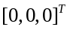 | Position of the robot base
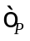 | 0.1 | End position accuracy error
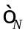 | 0.1 | End attitude accuracy error
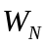 | 0.1 | The weighting factor for the number of modules in Eq.
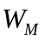 | 0.1 | Mass weighting factor in the equation
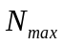 | 15 | Maximum number of modules that make up the robot
$P_O$ | 0.005 | Obstacle generation probability
$E_X$ | [-0.5, 0.5] | X-axis range of the task space ( Unit: m)
$E_Y$ | [-0.5, 0.5] | Y-axis range of the task space (Unit: m)
$E_Z$ | [0, 1] | Z-axis range of the task space ( Unit: m)

The PyBullet simulation engine was used to construct the training environment, which is shown in the simulation runtime interface in Figure ( Fig. 13). where a multi-degree-of-freedom robotic arm is generated at the origin, yellow dots indicate randomly generated target points, while orange cubes indicate obstacles. Figure 13(a) shows the role configuration of the robotic arm that successfully reaches the target point but the obstacle does not act as an obstacle. Figure 13(b) shows the configuration of the robotic arm that successfully avoids obstacles and reaches the target point. Figure 13(c) shows a failed operation of the robotic arm which fails to reach the target point.
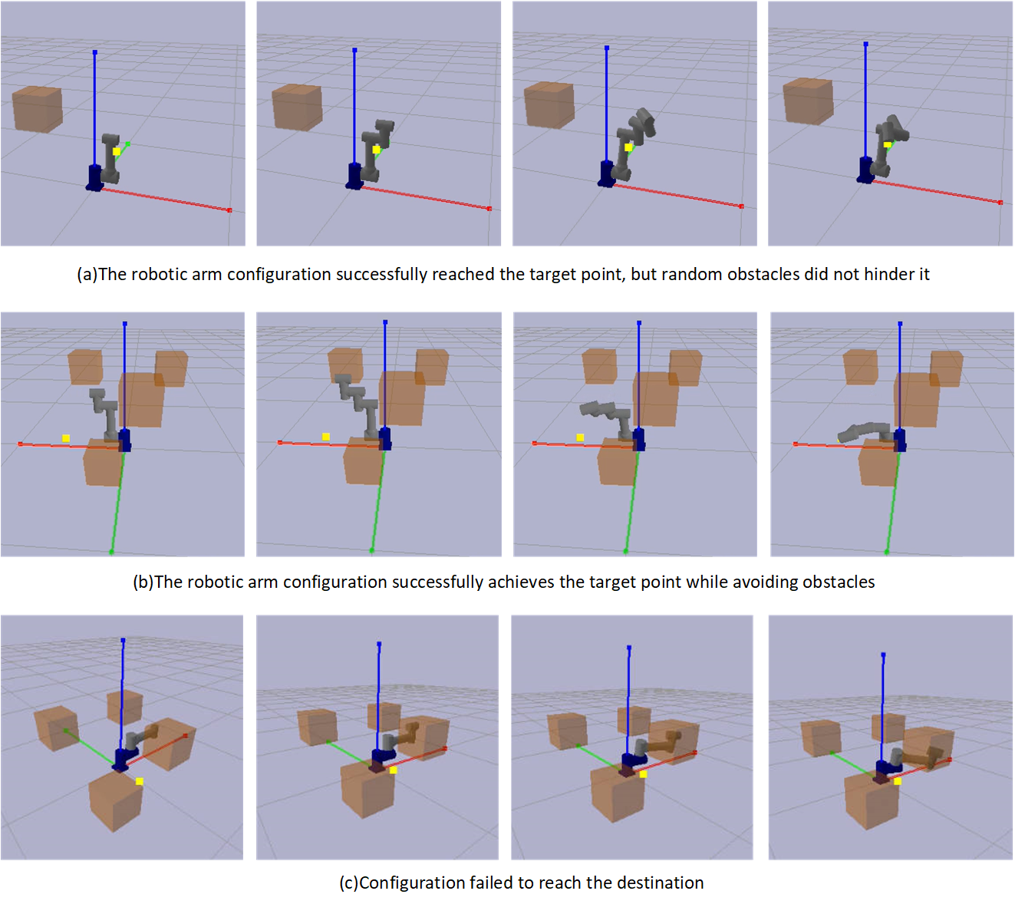
Fig.13 Simulation runtime interface

Results and Discussion
This experiment was conducted for a total of 80 epochs, each containing 150 interactions. Two different deep reinforcement learning algorithms were used for training in the same training environment and the variation of the loss function was plotted (Fig. 14). As shown by the figure, both algorithms were able to reach a state of convergence after a certain number of training rounds. While the traditional DQN algorithm starts to converge when the number of training steps approaches 1900 steps, there are large loss fluctuations before this point. While the improved DDQN algorithm converges faster and is able to reach a stable convergence around 500 steps, with its average loss value remaining below 2.5. Under the same training environment, the DDQN algorithm shows faster convergence speed and better stability than the traditional DQN algorithm, and its average loss value is also smaller. This indicates that the improved algorithm learns and optimises the Q-value function more efficiently during the training process, which enhances the learning ability and performance of the agent.
Fig.14 Loss Function Comparison

The maximum Q value of each selection in both algorithms is recorded as shown in Figure (Fig.15), which shows that the maximum Q value of both algorithms has the same trend and converges to near 12 after about 8000 steps of iteration. However, the average value of the maximum Q value of the DQN algorithm after convergence is 11.689, and the average value of the maximum Q value of the improved DDQN algorithm is 11.302, which indicates that the DDQN algorithm successfully mitigates some of the over-estimation when solving the problem of too high Q value and inaccurate target Q value in network training, and the algorithm is more accurate in estimating and updating the Q value function in the training process，which improved the performance and stability of the algorithm.
Fig.15 Maximum Q Comparison

The ultimate goal of both deep reinforcement learning algorithms is to maximize the target reward, therefore, comparing the average reward values obtained by the two algorithms, as shown in Figure (Fig.16), it can be observed that both curves show an increasing trend and stabilize after more than 30 training rounds. The average reward value of the DDQN algorithm converges near about 9 and the average reward sum over 80 training rounds is 485.026. while the average reward value of the DQN algorithm converges near about 8 and the average reward sum over 80 training rounds is 378.511. In addition, the DDQN algorithm produced higher average reward values than the DQN algorithm in the vast majority of cases. This suggests that the DDQN algorithm learned a better strategy and was able to select more efficient actions in the environment, thus increasing the overall reward of the agent. This also validates the effectiveness of the improved DDQN algorithm and further demonstrates its better learning ability and adaptability relative to the traditional DQN algorithm.
Fig.16 Comparison of average reward values

The study aims to verify the effectiveness of the proposed algorithm on the modular reconfiguration of robotic arms and to evaluate the performance of the new algorithm in solving the modular reconfiguration problem of robotic arms. During the study, a total of 50 groups of randomized tests were generated, with each group of targets containing a grid of up to five random obstacles. In each group, a target point was randomly generated through a normal distribution, and the configuration that successfully reached the target point was defined as the feasible configuration for the following data comparison:
(1) The probability of successfully finding a feasible configuration;
(2) The average number of modules of a feasible configuration;
(3) Average module quality of feasible configurations;
(4) Average time to find a feasible configuration;
The results of the comparative experiment are shown in Table (Table 5.):

Table 5. Comparison Test Results
Algorithm | The probability of finding a configuration | The average module quality | The average number of modules | The average time  (Unit: seconds)
Traditional DQN  algorithms | 24% | 7.23 | 7.88 | 7.807
DDQN + PER  algorithms | 32% | 5.92 | 6.14 | 7.984

The traditional DQN algorithm succeeded in finding complete configurations in 12 out of 50 sets of tests, while the proposed algorithm found 16 sets of complete configurations. Comparing the average module mass of complete configurations, it can be obtained that the average mass of complete configurations obtained by the proposed algorithm in this paper is about 5.92kg, and the average mass of complete configurations obtained by the traditional DQN algorithm is about 7.23kg, and the method in this paper decreases the average mass of robotic arm modules by about 18.11%. Comparing the average number of modules for the complete configuration, the algorithm proposed in this paper has 1.74 fewer average modules compared to the traditional DQN algorithm. Comparing the average time to find a feasible configuration, the two algorithms are comparable, to the average time to find a complete configuration for the first 12 groups of the two algorithms (Fig.17).
Fig.17 Comparison of times to find the complete configuration

Through the above comparative test results, shown results are: compared to the traditional DQN algorithm, the algorithm proposed in this paper has a higher probability of successfully finding feasible configurations, as well as the mass of feasible configuration modules is lighter and fewer, which means that the algorithm in this paper is capable of finding more feasible configurations that have lighter and more compact structures, and this advantage could lead to a higher efficiency and performance in practical applications.

Conclusion
In this paper, a DDQN modular robotic arm reconfiguration algorithm with prioritized experience playback is proposed, aiming to resolve the conflict that exists between diversity and economy in robotic arm design. The algorithm is improved by making improvements in terms of task customisation and robot economics, and comparative experiments are conducted with the traditional DQN algorithm. The results show that the algorithm can reduce the risk of overestimation of the Q-value and improves the convergence performance of the algorithm by prioritizing the empirical playback mechanism. This enables the modular robotic arm to achieve a higher success rate in the reconfiguration process while also improving the quality of the optimal configuration to adapt to complex and changing production environments and task requirements.
Future work could consider applying the algorithm to real robotic arm modules through migration learning and other methods to achieve modular robotic arm reconstruction in real scenarios. This will further validate the feasibility and effectiveness of the algorithm and explore its potential and limitations in practical applications.

References
- Wei J. Research on chained reconfigurable robotic arm for space on-orbit operation[D]. Harbin Institute of Technology, 2020.
- [2]Tu Yuanyuan,Wang Dayi,Zhang Xiangyan et al. Reconfigurability and autonomous reconfiguration methods for spacecraft[J/OL]. Journal of Aeronautics,pp:1-14,2023.
- [3] Luo H, Li M, Liang G, et al. An obstacle-crossing strategy based on the fast self-reconfiguration for modular sphere robots[C]//2020 IEEE/RSJ International Conference on Intelligent Robots and Systems (IROS). IEEE, 2020: 3296-3303.
- [4] Whitman J, Bhirangi R, Travers M, et al. Modular Robot Design Synthesis with Deep Reinforcement Learning[J/OL]. Proceedings of the AAAI Conference on Artificial Intelligence, 2020, 34(06): 10418-10425.
- [5] Schaul T, Quan J, Antonoglou I, et al. Prioritized experience replay[J]. arXiv preprint arXiv:1511.05952, 2015.
- [6] Zhai P, Zhang Y, Shaobo W. Intelligent Ship Collision Avoidance Algorithm Based on DDQN with Prioritized Experience Replay under COLREGs[J]. Journal of Marine Science and Engineering, 2022, 10(5): 585.
- [7] Liu S, Li X, Huang Yun. Research on NPC traveling route planning based on improved DQN algorithm[J]. Radio Engineering,vol:52(08),pp:1441-1446,2022.
- [8] Liu J, Wang YH, Wang L, Yin ZZ. A non-cooperative multiuser dynamic power control method based on SumTree sampling combined with Double DQN[J/OL]. Telecommunications Technology,pp:1-9,2023.
- [9] Liu J, Zhang X, Hao G. Survey on research and development of reconfigurable modular
- [10]Feder M, Giusti A, Vidoni R. An approach for automatic generation of the URDF file of modular robots from modules designed using SolidWorks[J]. Procedia Computer Science, 2022, 200: 858-864.
- [11] Van Hasselt H, Guez A, Silver D. Deep reinforcement learning with double q-learning[C]//Proceedings of the AAAI conference on artificial intelligence. 2016, 30(1).
[12] Liu J, Zhang X, Hao G. Survey on research and development of reconfigurable modular
[13] Mnih V, Kavukcuoglu K, Silver D, et al. Human-level control through deep reinforcement learning[J/OL]. Nature, 2015, 518(7540): 529-533.
[14] Van Hasselt H, Guez A, Silver D. Deep reinforcement learning with double q-learning[C]//Proceedings of the AAAI conference on artificial intelligence. 2016, 30(1).
[15] SCHAUL T, QUAN J, ANTONOGLOU I, et al. Prioritized Experience Replay[C]//ICLR 2016: International Conference on Learning Representations. San Juan: [s.n,], 2016:1-21.

